Mapping Microglia Parameters Software

Installation Guide

Introduction to installing and running Python-based software and scripts

MMPS is a Python-based software that can capture subtle microglial morphologies. One of the advantages of this program over others in the literature is that is designed to be easy, fast, user-oriented, and requires no coding experience! This is possible through packaging of the original script, Python language, and all dependencies into an executable file for Mac through PyInstaller. If using Windows, the python script itself must be used as the standalone app cannot run on Windows OS!

How to Download the Software for Mac (NO CODING NEEDED)
To download the app, visit our GitHub the “NeurodegenerativePharmaceuticalLab” and selecting the “Mapping-Microglial-Parameters-Software” repository. Alternatively, visit the link below.
https://github.com/NeurodegenerativePharmaceuticalLab/Mapping-Microglia-Parameters-Software
Here, all supporting documentation for software usage, plugin usage, and code can be found.
Once there, find the section labeled “Releases” as in the image below. A more direct link to this page is:
https://github.com/NeurodegenerativePharmaceuticalLab/Mapping-Microglia-Parameters-Software/releases/tag/v1.00

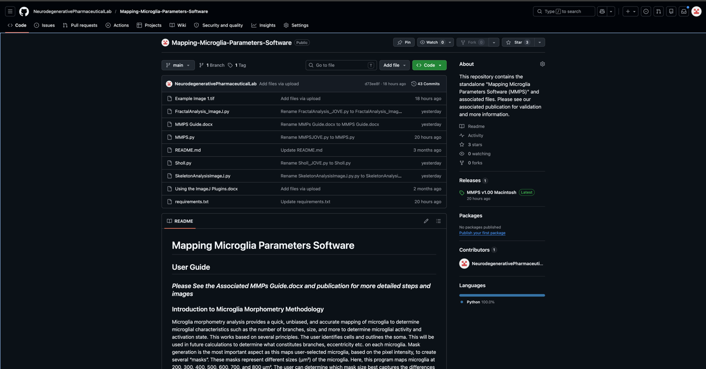

Once in this section, download the MMPS-v1.00-macos.zip. Once again, this will run ONLY on Mac operating systems. MMPS was designed for Macs with Mac OS Tahoe 26.1 or later with an Apple M3 chip or better. You can double-check your system capabilities on Mac by clicking the Apple icon in the top left bar and clicking “About This Mac” .

The zip file is almost 500 mb and will unpack to about 1.2 gb, so ensure there is enough computer memory for this. If memory issue cannot be fixed, running the individual python file and downloading the separate packages will take dramatically less space since it is not packaged (<150 mb).
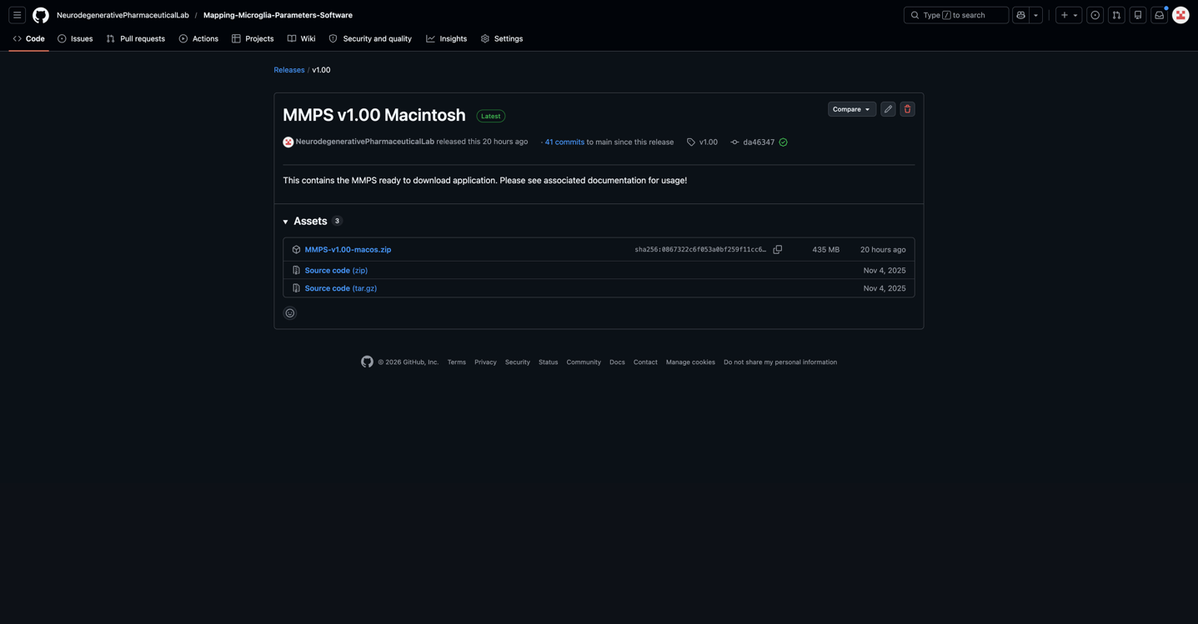

Find where it downloaded to (likely the “Downloads” folder). Double click to unzip it. It will give this message when unpacking.
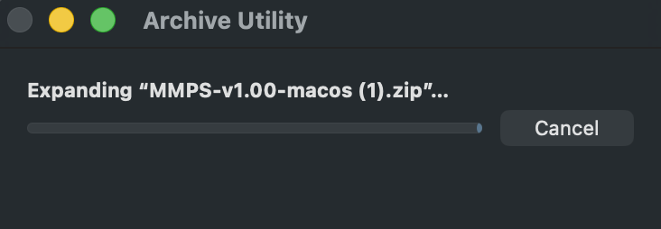

When done, you should see an app with a microglia icon called “MMPS v1.00” appear.

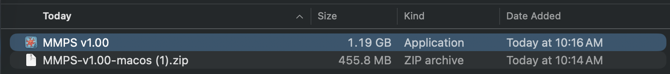

Save time for future use by dragging this to your home desktop screen. Double-click the app to open it.
You may receive a pop-up that asks if you are sure you want to open this. Click “Open” to fix this. You will not see this message again in the future.

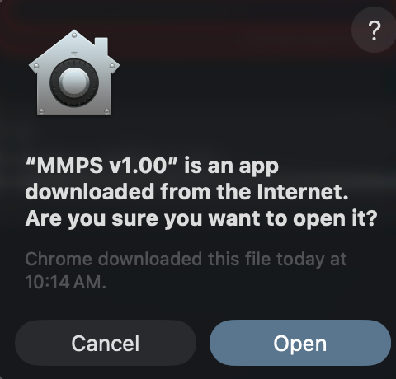
If an error appears that says Apple will not let you open it since it cannot verify it is malware free, you have two options. First, right-click the app and click “Open” or “Open Anyways”. If that option is not there nor works, go to Settings>Privacy and Security and there will be a message near the bottom that explains it blocked the opening of MMPS. Click “Open Anyways” there to overrule the blockage. You will not see this error message again.

Once inside, you should see the user interface!
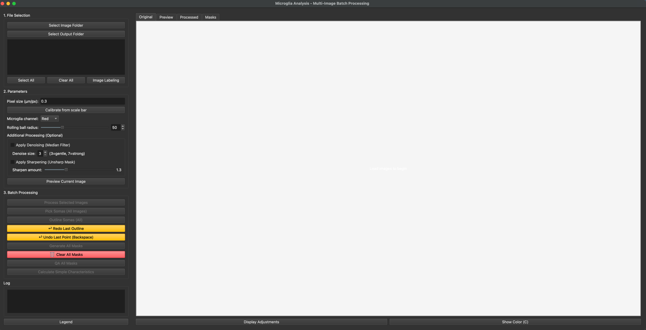
You are ready to start! You can now follow the JoVE publication or MMPS Guide.docx!

How to Download the Python Script and Execute it (Some coding knowledge needed)

Note: This approach takes a small amount of Python familiarity and coding knowledge.

To begin, go to https://www.python.org/downloads/macos/ for Mac users and https://www.python.org/downloads/windows/ for Windows users.
Download Python 3.11.1 or later and unpack it for your operating system. Mac is used as an example in the image below but do the same for Windows. It will ask you for installation permission. Allow it. Make sure to note how to find the part of the installation that says “IDLE”. This will be a shell to launch Python scripts from.

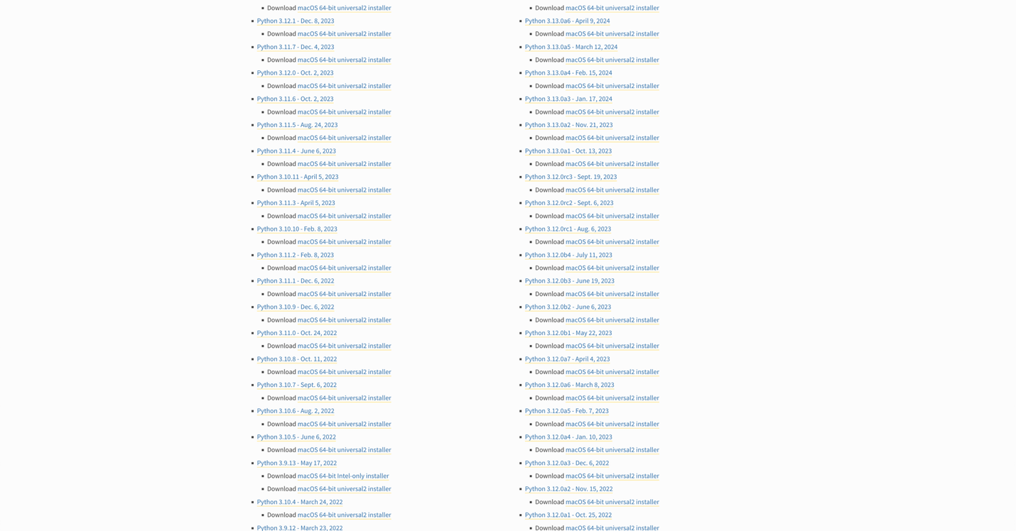

Now that Python is set up, we need to get the MMPS script to use with this. Once again, the MMPS app is designed to be ready to be used just by opening the zip file. However, if you would still like to launch it from the Python script directly, keep following the guide below.

First, visit our GitHub the “NeurodegenerativePharmaceuticalLab” and selecting the “Mapping-Microglial-Parameters-Software” repository. Alternatively, visit the link below.

https://github.com/NeurodegenerativePharmaceuticalLab/Mapping-Microglia-Parameters-Software

From here, look for two files: MMPS.py and requirements.txt


MMPS.py contains the same executable Python script that launches MMPS as the downloadable app does but does not include any packages used within nor the coding language itself.
Requirments.txt is a plain text file that contains the specific packages and versions needed to run MMPS. If you execute the MMPS script WITHOUT these packages, the script will error out. Again, the MMPS app avoids this by bundling them together for you. Next, we need to download the packages MMPS.py uses. This is what is contained in the requirements.txt file.
Once done, open the Python IDLE shell from earlier.
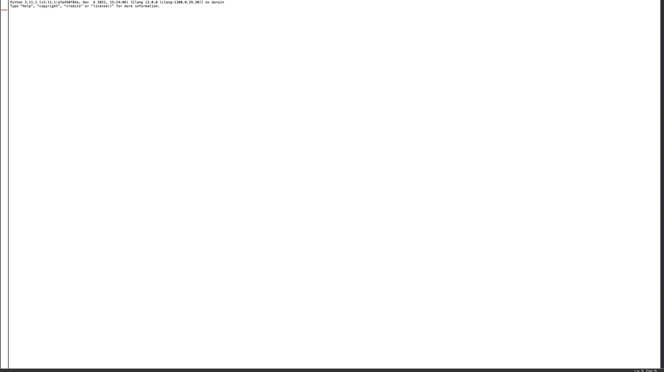

Now we need to install the packages MMPS.py uses. To do so:

TYPE OR COPY EACH LINE INDIVIDUALLY INTO THE SHELL, THEN HIT ENTER BEFORE MOVING TO THE NEXT LINE!
import subprocess
import sys
subprocess.check_call([sys.executable, "-m", "pip", "install", "-r", "/Users/dc00086/Downloads/requirements.txt"])

Notice the highlighted section. This is the path to your requirements.txt file. An example is provided, but the entire highlighted region must be updated with your path (our file is not saved in the exact same spot in your computer after all!). You can find the oath by right clicking the file and clicking “Get info” or “Copy path”.
When you run these lines, the last line may take some time as it is checking to see if the packages are already downloaded (most likely not if this is your first time with Python) and if they are not downloaded, it will do it for you. If a black screen appears with colored text, this is normal. That is the computer terminal downloading the packages, which you told it do so through the code you provided in the Python shell. Below is the example output. The “0” denotes it ran without error. If you see any other messages that state the package names, it is because they needed downloaded, whereas here, they have already been installed.

If this gives an error code in the third line stating that there was an encoding error, write these lines instead to bypass the encoding declaration requirement.
import subprocess
import sys
import os
req_path = r"C:\Users\YOUR_USERNAME\Downloads\requirements.txt"
python_exe = sys.executable.replace("pythonw.exe", "python.exe")

print(f"Using Python: {python_exe}")
print(f"Installing from: {req_path}")

if not os.path.exists(req_path):
print(f"ERROR: requirements.txt not found at {req_path}")
else:
print("Installing packages... this may take 3-5 minutes.\n")

env = os.environ.copy()
env["PYTHONIOENCODING"] = "utf-8"

subprocess.check_call(
[python_exe, "-m", "pip", "install", "-r", req_path],
encoding="utf-8",
errors="replace",
env=env
)

print("\nAll packages installed successfully.")

Next, run this statement to check if they are loaded correctly.
import numpy, PIL, tifffile, skimage, scipy, matplotlib, cv2, PyQt5
If there is no error, you are ready for the next step. If not, repeat the prior download steps again. Now, you are finally ready to run the MMPS.py script. Paste this in the shell,

exec(open('/Users/dc00086/Downloads/MMPSJOVE.py').read())

If that returns errors, run this code below:
import subprocess
import sys
import os

script_path = r"C:\Users\YOUR_USERNAME\Downloads\MMPS.py"
python_exe = sys.executable.replace("pythonw.exe", "python.exe")

if not os.path.exists(script_path):
print(f"ERROR: MMPSJOVE.py not found at {script_path}")
else:
print(f"Launching MMPS from: {script_path}")

env = os.environ.copy()
env["PYTHONIOENCODING"] = "utf-8"

subprocess.Popen(
[python_exe, script_path],
env=env
)

print("MMPS launched. The GUI window should appear shortly.")
Once again, replace the highlighted section with your file path. When complete, you should see MMPS opened!



You can now proceed to the JoVE article or the MMPS Guide.docx!

